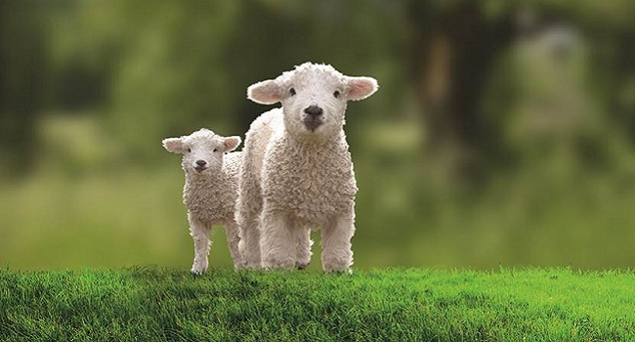

**Activities**

Dear visitors,

**Hello and welcome to the Allan shanks farm!**

Located between the capital city of Scotland–Edinburgh and Carlisle. We bring to you one of the most entertaining leisure farm sites across Scotland.

Our variety of facilities means that there’s bound to be a thing for you ! ( for further information on the farm click on ‘the farm’ tab)

……………………………

………………………………………………………

News & Events

Welcome!

**Allan Shanks Farm**

HOME

Contact & Info

Shop

The Farm

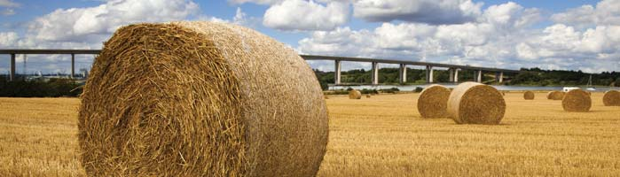

Allan Shanks Farm

The Farm

Stuff………………………………………………………………………………………………….

* Introduction on
  + The zoo
  + Café
  + Play Park
  + Walks
* (consider creating individual webpages for each/ The zoo +playpark &walk +café)

Contact & Info

Shop

**The Farm**

News & Events

HOME

News and events

BgImage

Contact & Info

Shop

News & Events

The Farm

HOME

Allan Shanks Farm

Stuff………………………………………………………………………………………………….

……………………………………………………..and lots of photos

…………………………………………………………………….. ANIMAL PICTURE

…………………..

……………………………

………………………………………………………

The FarM

BgImage

Contact & Info

Shop

News & Events

The Farm

HOME

Allan Shanks Farm

Stuff………………………………………………………………………………………………….

……………………………………………………..

……………………………………………………………………..

…………………..All sorts of shop stuff

……………………………

………………………………………………………

shop

BgImage

Contact & Info

Shop

News & Events

The Farm

HOME

Allan Shanks Farm

**Contact & Info**

Opening Times:

Contact Details:

* Telephone
* Email
* Facebook

Location:

**Interactive Gmap**

Stuff………………………………………………………………………………………………….

……………………………………………………..

……………………………………………………………………..

…………………..

……………………………

………………………………………………………